Handout 7: Writing Custom Functions
As previously mentioned, R has many, many built in functions for the management and analysis of data. This handout will discuss how to create custom functions.
> #Getting a vector of random data
> set.seed(987654321)
> x<-runif(20,0,1)
>
> #Compute median of x
> median(x)
[1] 0.5365624
Before we discussing writing new functions in R, let’s examine an existing function more closely. For more insight into the coding behind the median() function, consider the following R commands and output.
> median
function (x, na.rm = FALSE)
UseMethod("median")
<bytecode: 0x000000000b265d20>
<environment: namespace:stats>
> methods(median)
[1] median.default
> median.default
function (x, na.rm = FALSE)
{
if (is.factor(x) || is.data.frame(x))
stop("need numeric data")
if (length(names(x)))
names(x) <- NULL
if (na.rm)
x <- x[!is.na(x)]
else if (any(is.na(x)))
return(x[FALSE][NA])
n <- length(x)
if (n == 0L)
return(x[FALSE][NA])
half <- (n + 1L)%/%2L
if (n%%2L == 1L)
sort(x, partial = half)[half]
else mean(sort(x, partial = half + 0L:1L)[half + 0L:1L])
}
When determining how to use this function, note that this function contains two arguments: x and na.rm. For more information on these arguments, you should review the help documentation for median.
> help("median")
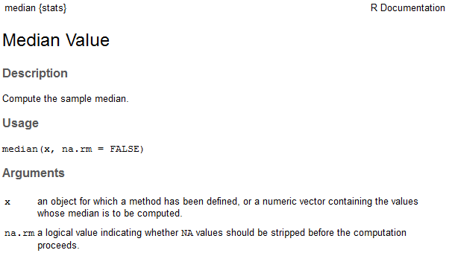

Notice that by default, the na.rm argument is set to FALSE. This means that the following arguments both return the same result:
> median(x)
[1] 0.5365624
> median(x,na.rm=FALSE)
[1] 0.5365624
The previous example gives us some insight into how functions are written with arguments that are called within R. You can learn a lot about R programming by examining the code behind functions that were written by others. The remainder of this handout provides an introduction to the basics of writing your own functions in R.
WRITING NEW FUNCTIONS IN R
One of the advantages of using a scripting language like R is the ability to write your own functions (or to modify existing functions). An R programmer can define their own functions using the function() and return() functions.

Example 1: Creating a function to add two numbers
Note that the sum() function already exists in R and can be used to add two numbers; for illustrative purposes, however, we will write our own simple function to do this.
> #Add two function
> add_two <- function(a,b){
+ a+b
+ }

To call the function, enter the following at the prompt.

> add_two(3,9)
[1] 12
Example 2: Creating a function to compute multiple quantities
Next, suppose you want to write a function in R to both find the difference between two values and the ratio of those two values. You may start with the following.
> f1 <- function(a,b){
+ a-b
+ a/b
+ }

> f1(4,2)
[1] 2

Note that the function returns the result of only the last of the computations. To report all of the results, you can use the return statement as shown below.
> f1 <- function(a,b){
+ return(c(a-b, a/b ))
+ }

> f1(4,2)
[1] 2 2

Finally, note that it may be more useful to assign names to the values calculated and to return a more flexible data type (such as a list object) to provide more information about the calculations that have been performed. The following programming statements return the results in a list.
> f1 <- function(a,b){
+ Result1 = a-b
+ Result2 = a/b
+ list(Difference=Result1,Ratio=Result2)
+ }

> f1(4,2)
$Difference
[1] 2
$Ratio
[1] 2
Example 3: Creating a function with default values
Next, suppose you want to write a function in R to both find the product of two values. If parameters of the function are not provided, then default values are to be specified.
> Myproduct <- function(x=1,y=1){
+ result = x*y
+ return(result)
+ }
Using this function with x=10 and y=5
> Myproduct(x=10,y=5)
[1] 50

Using the default parameter values
> Myproduct()
[1] 1

Using this function with x=10 and (y=1, the default value)
> Myproduct(x=10)
[1] 10

Example 4: Computing the mean of a vector of numbers
Once again, note that the mean() function already exists in R and can be used to find the average of a vector of numbers; for illustrative purposes, however, we will write our own simple function to do this. Suppose we want to name our function average. We can check to make sure that this is not already a keyword in R (we wouldn’t want to overwrite an existing function!).
> ?average
No documentation for ‘average’ in specified packages and libraries:
you could try ‘??average’

Next, we can write the function as follows.
> average <- function(x){
+ s = sum(x)
+ avg = s/length(x)
+ return (avg)
+ }

Note that this function can now be applied to calculate the average of any vector in R.
> average(x)
[1] 0.4783486
Example 5: Dealing with missing values
Missing values should be considered when writing custom functions. For example, the average() function written above will not work with missingness present.
> x[2]<-NA
> x
[1] 0.36888095 NA 0.54802340 0.17993140 0.65435477 0.12500433 0.52510142 0.35084670 0.70311331
[10] 0.73129676 0.61784387 0.52065692 0.75065050 0.58954068 0.65485598 0.07954121 0.30900394 0.79808945
[19] 0.07708921 0.17460408
> average(x)
[1] NA
Missing values can be dealt with easily in this simple case by adding na.rm=TRUE to the sum() function. In addition, na.omit() will be used to omit any missing values when computing the length of the vector.
> average <- function(x){
+ s = sum(x, na.rm=TRUE)
+ avg = s/length(na.omit(x))
+ return (avg)
+ }

> average(x)
[1] 0.4609699

A check to make sure NA is being properly ignored. The x[-2] syntax simply removes the second element to x.

> average(x[-2])
[1] 0.4609699
Example 6: Modifying the summary() function
R allow us to expand upon existing functions. Consider the following in which the summary() function is being applied to a data.frame.
> set.seed(987654321)
> x<-runif(20,0,1)
> summary(x)
Min. 1st Qu. Median Mean 3rd Qu. Max.
0.07709 0.27670 0.53660 0.47830 0.66690 0.80850

We will now add to the standard list of summaries the standard deviation, mean absolute deviation, and the count. The following code will add these summaries to standard output provided by the summary() function.
> num.summary <- function(x){
+ original = summary(x)
+ stdev = sd(x,na.rm=TRUE)
+ mean.abs.dev = mean(abs(na.omit(x)-mean(na.omit(x))))
+ n=length(na.omit(x))
+ list(c(original,"Std Dev" = stdev, "MAD" = mean.abs.dev,"Count"=n))
+ }

The modified summary function includes the additional summaries.
> num.summary(x)
[[1]]
Min. 1st Qu. Median Mean 3rd Qu. Max. Std Dev MAD Count
0.0770900 0.2767000 0.5366000 0.4783000 0.6669000 0.8085000 0.2498250 0.2161887 20.0000000

Finally, note that you could change the layout of the output. The paste() and round() functions are used here for writing to the screen and for rounding output.
> num.summary <- function(x){
+ Min = summary(x)[1]
+ Q1 = summary(x)[2]
+ Q2 = summary(x)[3]
+ Q3 = summary(x)[5]
+ Max = summary(x)[6]
+ Mean = summary(x)[4]
+ s = sd(x,na.rm=TRUE)
+ mean.abs.dev = mean(abs(na.omit(x)-mean(na.omit(x))))
+ n=length(na.omit(x))
+ cat(paste("Min: ", Min))
+ cat("\n")
+ cat(paste("Q1: ", Q1))
+ cat("\n")
+ cat(paste("Median: ", Q2))
+ cat("\n")
+ cat(paste("Q3: ", Q3))
+ cat("\n")
+ cat(paste("Max: ", Max))
+ cat("\n")
+ cat(paste("Mean: ", Mean))
+ cat("\n")
+ cat(paste("Standard Deviation: ", round(s,4)))
+ cat("\n")
+ cat(paste("Mean Absolute Deviation: ", round(mean.abs.dev,4)))
+ cat("\n")
+ cat(paste("Sample Size: ", round(n,0)))
+
+ }

The output with custom printing.
> num.summary(x)
Min: 0.07709
Q1: 0.2767
Median: 0.5366
Q3: 0.6669
Max: 0.8085
Mean: 0.4783
Standard Deviation: 0.2498
Mean Absolute Deviation: 0.2162
Sample Size: 20

Example 7: Modifying the plot() function

Consider the following data and its associated plot.
> #Getting a vector of random data
> set.seed(987654321)
> x<-runif(20,0,1)
> y<-2 + 3*x + runif(20,-0.5,0.5)
>
> plot(x,y)

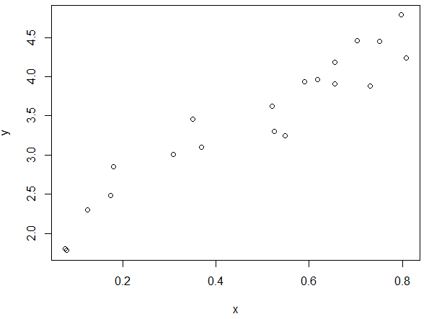

Suppose you want the plot() function to use a very large triangle plotting character that is red. The plot() function can be modified as follows. R allows you to pass an unspecified number of parameters to a function using the … notation. Note: One should carefully consider the order of the arguments in the list when using the … notation.
> myplot <- function(..., pch.new=2, col.new="red", cex.new=4.0 ) {
+ plot(..., pch=pch.new, col=col.new, cex=cex.new )
+ }
>
> #USing the new plottign function
> myplot(x,y)

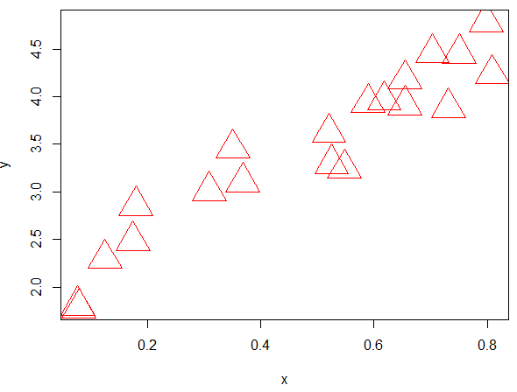
Tasks:
- Recall that the formula for a sphere is ⁴⁄₃πr³. Write a function named sphere.volume that returns the volume of a sphere when given the radius r as a parameter. Then, call the function to return the volume of a sphere with a radius of 5. Call the function again to return the volume of a sphere with a radius of 10.
- Write a function named myplot which calls the plot() function but uses a blue open circles as the default plotting symbol. Create a plot using your new myplot() function.

