The previous handout provided an overview of study designs. The two broad classifications discussed were randomized experiments and observational studies. In this handout, we will briefly introduce a specific type of observational study, i.e. a survey. Specific issues regarding survey design will be discussed in future handouts. Here, we will discuss various sampling techniques that can be used to select potential respondents to a survey.
INTRODUCTION TO SURVEYS
Surveys are used everywhere and for many reasons. For example, surveys are commonly used to track the following:
- Issues of Concern to the Government (http://www.census.gov/programs-surveys.html)
- Business/Industry
- Opinions (http://www.gallup.com)
Surveys (and observational studies, in general) can be broadly classified into two types:
Broad Classifications of Survey/Observational Studies
Descriptive – The objective of a descriptive survey study is simply to obtain certain information about a population of interest.
Analytical – The objective of an analytical survey study is to make comparisons between different subgroups of a population.
Note that many surveys will provide data that can serve both of the above purposes.
SOME TERMINOLOGY
Terminology Used in Survey Studies
Target Population – Ask yourself the following question: to whom do you want to generalize the results? This group is the target population. Ideally, this is the group from which you’d like to sample.
Study Population - Sometimes, the target population is hard to access, and only some of the target population will be available for the study. This (typically nonrandom) subset of the target population is known as the study population (or the accessible population).
Sampling Frame - The sampling frame is a list of all elements (called sampling units) of the study population that will be used for sampling. Sometimes this is people, sometimes it is households, etc. This is needed so that every sampling unit in the population is identified so they will have an equal opportunity for selection.
Sample – The sample consists of the elements from the study population that are actually selected to participate in the study. When a survey study involves people, these elements are typically referred to as subjects or participants. Finally, note that not necessarily all of the subjects selected for a sample will choose to participate in the study!

All of these terms are summarized in the following figure.
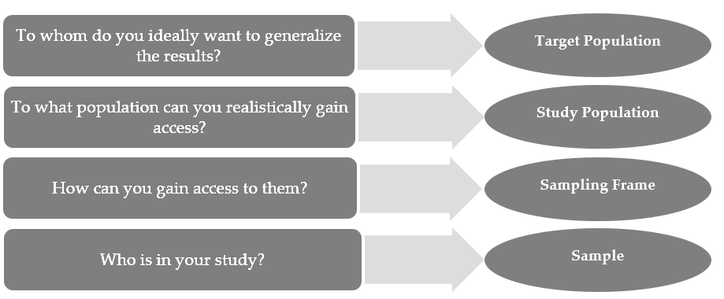
The following examples provide some context to this terminology.
 | Target Population | Study Population | Sampling Frame
Example 1: | All institutionalized elderly persons with Alzheimer’s | All institutionalized elderly persons with Alzheimer’s in Winona county nursing homes | A list of all institutionalized elderly persons with Alzheimer’s in Winona county nursing homes
Example 2: | School-age children with asthma | School-age children with asthma treated in pediatric asthma clinics in university-affiliated medical centers in the Midwest | A list of all school-age children with asthma treated in pediatric asthma clinics in university-affiliated medical centers in the Midwest
Example 3: | All American adults (age 18 or older) | All American adults age 18 or older who have a telephone | A list of traditional land-line and cell phone numbers of American adults

STEPS INVOLVED IN PLANNING A SURVEY
In his book Sampling Techniques, William G. Cochran outlines the many steps that are involved in planning a survey.
- Define the objectives of the survey study
- Define the target population and the study population (hopefully they coincide)
- Determine what data must be collected to address the objectives of the survey study (e.g., are any questions unnecessary? Are all questions that need to be asked included?)
- Decide on a sample size
- Decide on the method of measurement (e.g., will the survey be self-administered, interview, mail, telephone, etc.?)
- Create the sampling frame
- Select the sample
- Do a “pre-test” with the survey
- Organize the field work
- Collect and summarize/analyze the results
- Note lessons learned for the future
In future handouts, we will discuss in detail many aspects of designing a survey. For now, however, we fill focus primarily on the sampling process.
SAMPLING METHODS
Our overall objective when sampling is as follows:
The goal is to obtain a good sample so that we can draw sound conclusions about the population. It is essential that our sample be representative of the population!

Example: The Literary Digest and Presidential Elections
“The Literary Digest conducted polls regarding the presidential elections in 1920, 1924, 1928, and 1932, making correct predictions of the winner for each. In the 1936 election they decided to conduct their most ambitious poll and collected responses from over two million people. Using this information they predicted that Alf Landon would win the 1936 presidential election over Franklin Roosevelt. Franklin Roosevelt, however, ended up winning the presidency with 61 percent of the votes. The Literary Digest was left wondering what went wrong. There was also a gentleman named George Gallup who also conducted a poll and correctly predicted that Roosevelt would win the presidency. You might wonder what George Gallup did to end up with a correct prediction while the Literary Digest seemed to bobble after years of correct predictions. It turns out the difference in the polls conducted was the manner in which the samples were chosen. The Literary Digest used telephone directories and lists of automobile
owners to select their participants who consisted mostly of wealthy individuals, whereas Gallup
tried to get a sample which represented characteristics of the population. Most of the lower class individuals voted in favor of Roosevelt because he was proposing the New Deal recovery program, which was very desirable since the country was just coming out of the worst economic recession they had seen at the time.“
Source: Babbie, Earl. The Basics of Social Research, 5th Edition. 2011. Wadsworth, p. 204 – 205.

The key to making a correct prediction in the 1936 presidential election was the ability to get a representative sample of the population of interest. Sampling theory makes the process of obtaining a representative sample and then estimating parameters of interest extremely efficient. Methods of sample selection and estimation have been developed to provide the most precise estimates at the lowest cost. Next, we will discuss some of these sampling techniques.
Two types of sampling exist, in general.
Broad Classifications of Sampling
Probability Sampling – This uses some form of random selection, and each unit is drawn from the population with a known, non-zero probability.
Nonprobability Sampling – This does not involve random selection, and the probability of selecting each unit from the population is either unknown or, in some cases, zero.
Next, we will discuss commonly used probability sampling methods. In general, we’ll use the following notation:
- N = the number of units in the sampling frame
- n = the number of units in the sample
Probability Sampling Methods
The simplest and most common probability sample is known as a simple random sample (SRS).
Simple Random Sampling
When obtaining a simple random sample, researchers select n units from N objects such that each possible sample of size n has an equal chance of being selected.

Questions:
  - One example of simple random sampling is as follows. Suppose researchers intend to survey 100 employees out of a business with 1,000 employees. How could this be accomplished?
  - Suppose a professor takes the first 10 students on the class list (which is organized alphabetically) and surveys them to find out their opinions of the course so far. Is this a simple random sample?
  - What if the professor uses the class list but this time randomly chooses a letter from the English alphabet and selects for the sample those students whose last name begins with that letter?
  - Suppose that instead of using the class list, the professor picks a digit at random and selects for the sample those students with phone numbers ending in that digit. Is this a simple random sample?
In general, simple random sampling is simple to accomplish and easy to explain. It is a fair sampling method, and it’s reasonable to assume the sample is representative of the population (and therefore we can generalize the results from the sample back to the population). This method, however, is not the most efficient method of sampling. Also, by luck of the draw in some cases, we may not get a good representation of the subgroups in the population. To deal with these issues, alternative sampling methods are often used.
The next method ensures that we get a good representation of the subgroups in the population.
Stratified Random Sampling
A stratified random sample is obtained by first dividing the population into homogeneous subgroups (called strata) and then taking a simple random sample from each subgroup.
Variables often used to create strata include age, gender, ethnicity, socioeconomic status, diagnosis, geographic region, etc.

There are two approaches to obtaining stratified random samples: proportionate and disproportionate.
Two Approaches for Stratified Random Sampling
To obtain a proportionate stratified random sample, the subgroup sample sizes are set equal to the proportions of the subgroup within the study population.
For example, Winona State University consists of about 40% males and 60% females. If we were to survey 100 WSU students and felt that they might answer questions differently based on their sex, we might want to randomly select and survey 40 males and 60 females.
To obtain a disproportionate stratified random sample, the subgroup sample sizes would not be set equal to the proportions of the subgroup in the study population.
For example, in some studies, researchers may want to oversample minority groups so that they can ensure enough minority subjects are obtained to draw conclusions about those subgroups. Note that when obtaining overall estimates regarding the population, the researchers would adjust the estimates based on the fact that some groups were oversampled. This type of complex analysis is beyond the scope of this course, but it’s important to recognize that it is used by statisticians with expertise in surveys and sampling.
The stratified random sampling procedure comes with the following advantages and disadvantages.
Advantages of Stratified Random Samples
- They ensure that the sample is representative of the population in terms of the stratification variable. Essentially, they “protect” us from the unlikely but still possible scenario of obtaining a biased sample through simple random sampling.
- They generally lead to more precision on estimates than do simple random samples, as long as the groups are homogeneous. How much the stratification helps depends on the relationship between the variable(s) used to create strata and the outcomes of interest in the study. The stronger this relationship, the more we gain from using a stratified sampling method.
- They allow us to obtain estimates with a certain precision for specific subgroups of the population.

Disadvantages of Stratified Random Samples
- They are more complex and require slightly more effort than simple random samples
- The strata must be carefully defined

Example: Stratified Random Sample of Nurse/Midwives
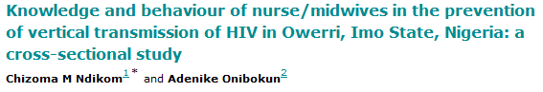
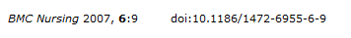
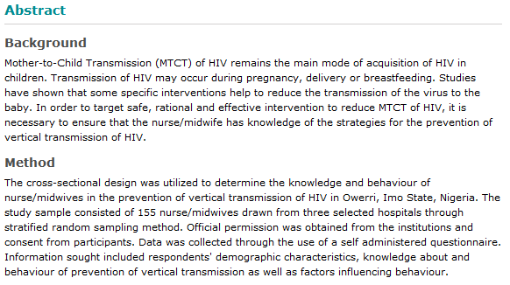
Questions:
- What stratification variable was used?
- Why would the researchers choose to use this variable?

Questions: What stratification variable(s) might be used for the following situations?
- Researchers want to conduct a poll to estimate the percentage of registered voters in MN that will vote for Governor Mark Dayton in the upcoming election.
- Researchers want to estimate the amount of money students spend on textbooks in a given semester. They plan to conduct an email survey.

The next sampling method we’ll discuss is another example of a probability sampling method.
Systematic Random Sampling
A systematic random sample is obtained by first numbering the units in the sampling frame from 1 to N. Once the researcher has decided on the n that is needed, they calculate k = N / n. Finally, they randomly select an integer from 1 to k and then select every k^{th} observation from that point on.
Note that if the units in the sampling frame are randomly ordered, this is essentially the same as simple random sampling. In this case, we could safely assume the sample is representative of the population. The main advantage of systematic random sampling is that it can be quickly and easily implemented; the main disadvantage is that the method might lead to bias if there are hidden periodicities in the sampling frame.
The final basic probability sampling method is discussed below.
Cluster Random Sampling
A cluster random sample is obtained by first dividing the study population into clusters (typically geographically). Once clusters have been formed, a simple random sample of clusters is taken. All units within the sampled clusters then form the sample.
Main Advantage of Cluster Random Samples
- They make the sampling process much more efficient, especially when the population is dispersed across a wide geographic region.
Disadvantages of Cluster Random Samples
- They are the least representative of the population out of all of the types of probability samples discussed so far. Units within a cluster may have similar characteristics, which could lead to an over- or under-representation of certain characteristics in the sample.
- They are typically associated with high sampling errors.
- They lead to a violation of the assumption of independence, so the analysis of data collected from cluster sampling methods is slightly more complex.

Now that we have discussed the four basic types of probability sampling, consider one last probability sampling approach: multi-stage random sampling.

Multi-Stage Random Sampling
The four previously discussed probability sampling methods are the simplest random sampling strategies. In most real, applied research, the sampling methods used are more complex. The previously discussed methods can be combined in a variety of ways to create what the researchers feel is the most efficient and effective sampling method. When sampling methods are combined, this is called multi-stage sampling.

Example: Multi-Stage Sample of U.S. Physicians Counseling Adolescents About Smoking
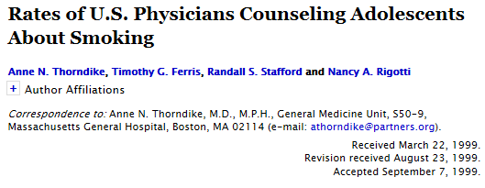
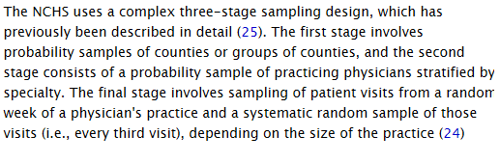

Main Advantage of Probability Sampling Methods, Overall

Probability sampling methods allow us to estimate sampling errors.
Definition
A sampling error is the discrepancy between the sample statistic and the population parameter of interest that is due to random fluctuations in the data that occur when the sample is selected.

When a probability sampling method is used, we can obtain an estimate of the sampling error which represents the magnitude of the uncertainty regarding the obtained parameter estimate.
In general, for simple random samples, the sampling error is computed as follows (note that this was probably called the standard error in your introductory statistics course):

Once this has been calculated, it can be used to construct a confidence interval. Once again, this standard formula for calculating the sampling error is based on the assumption that the sample was drawn using simple random sampling. When another probability sampling method has been used, the sampling error may actually be slightly higher (or lower) than indicated by the standard formula. For example, the sampling error for cluster sampling will be higher than the sampling error for simple random sampling. For stratified designs, on the other hand, the sampling error will be lower. The overall message is this: care should be taken to use the correct standard errors in an analysis. Once again, these analyses are beyond the scope of this course; however, you should recognize the importance of their use by professional statisticians.
Nonprobability Sampling Methods
As mentioned previously, nonprobability sampling methods do not involve any element of randomness. With these types of sampling procedures, some elements in the population have a zero probability of being selected or an unknown probability of being selected. This doesn’t automatically imply that the samples obtained aren’t representative of the population, but it is much more difficult to justify that they are than it is for probability samples. The bigger issue is this: traditional probability theory does not apply to these samples, and so the sampling error can’t be estimated. Therefore, no valid confidence intervals can be obtained, either! Probability sampling methods give us much more confidence that we have represented the population well, and they allow for the estimation of sampling errors (and thus margins of error and confidence intervals). Sometimes, however, it is not feasible to take probability random samples. In such cases, the researchers may use one of the following nonprobability sampling methods.

Convenience Sampling
Obtaining a convenience sample involves selecting the most readily available elements of a population for a study.
For example, in a clinical study, researchers may use patients that are easily accessed. Or, a study may ask for (or even recruit and provide monetary compensation to) volunteers. In such cases, there is concern about whether these samples are representative of the population (and maybe even suspicion that they are not). For example, one concern regarding opinion polls is that people who volunteer might tend to be more interested in (and therefore more knowledgeable or opinionated about) the survey topic than the general public.

Purposive Sampling
When obtaining a purposive sample, researchers “hand-pick” units from the study population that they believe to be representative of the population.
For example, in order to study consumer preferences of Caucasian females age 30-40 years old, market researchers may go to a shopping mall and seek out individuals who seem to fit this category. Or, suppose researchers want to estimate the average amount a shopper spends in one visit to the Mall of America. If purposive sampling is used, the researcher will look around and use their own judgment to sample shoppers who they feel are representative of the population.
Purposive sampling allows researchers to reach a targeted sample quickly; however, samples may not be representative of the population because the sample is likely to overweight subgroups of the population that are more readily available.
Snowball Sampling
This is a variant of purposive sampling. To obtain a snowball sample, a few members of the population who meet criteria for inclusion in the study are selected, and they are asked to provide names of further subjects they know who also meet the criteria.

This will most likely yield unrepresentative results; in some cases, however, it may be the only way to reach a population that is hard to access.

Example: Snowball Sample to Investigate Reasons for Drug Use Amongst Young People
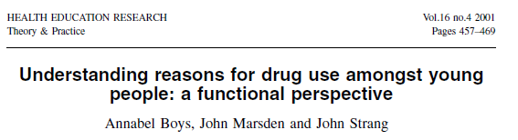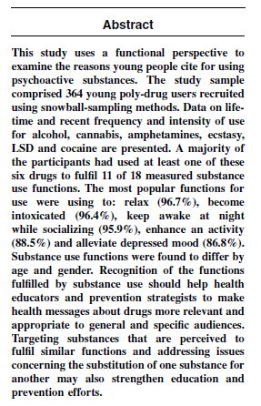

Quota Sampling
A quota sample is selected non-randomly according to some fixed quota which is set to reflect certain characteristics of the population.

For example, if a population consists of 40% men and 60% women and a sample of size 100 is desired, researchers recruit the first 40 men and 60 women that meet the inclusion criteria. This is similar to stratified sampling but does not involve random selection; so, it ensures selection of adequate numbers of subjects from each subgroup. The sample, however, may not be representative of the population.

TYPES OF ERRORS THAT OCCUR IN SURVEY STUDIES

There are two types of errors that typically occur with survey studies:
Broad Classifications of Errors
Sampling Errors – As discussed earlier, when parameters of a population are estimated from a subset of that population (the sample), the statistics calculated from the sample data will generally differ from the parameters of the entire population. This type of error is unavoidable, but it decreases as the sample size increases.
Non-sampling Errors – This refers to any other deviations from the population parameters that are not due to sampling error. These are much harder to quantify.
Next, we will discuss some commonly encountered non-sampling errors.
Non-sampling Errors
Coverage Error – This includes both undercoverage and overcoverage. Undercoverage occurs when some members of the population are inadequately represented in the sample. A classic example of undercoverage is the Literary Digest voter survey, which predicted that Alfred Landon would beat Franklin Roosevelt in the 1936 presidential election. The survey sample suffered from undercoverage of low-income voters, who tended to be Democrats. Also, in many surveys of households, subgroups such as members of the military or persons who are institutionalized tend to be undercovered. Overcoverage occurs when some members of the population are overly represented in the sample. The classic example of this is when the data frame contains duplicate records.
Some researchers just ignore these types of error, which isn’t necessarily a good idea. Others are careful to redefine their study population or make corrections to their sampling frame. Finally, some consult with professional statisticians with survey expertise who can use advanced statistical techniques to adjust for coverage errors.
Non-Response Error - Sometimes, individuals chosen for the sample are unwilling or unable to participate in the survey. Nonresponse bias is the bias that results when respondents differ in meaningful ways from nonrespondents. The Literary Digest survey illustrates this problem, as well. Respondents tended to be Landon supporters; and nonrespondents were Roosevelt supporters. Since only 25% of the sampled voters actually completed the mail-in survey, survey results overestimated voter support for Alfred Landon.
Again, some researchers just ignore this type of error, which isn’t necessarily a good idea. Others consult with professional statisticians with survey expertise who can use advanced statistical techniques (such as data imputation) to adjust for non-response errors.
Voluntary Response Error - This occurs when individuals select themselves to participate in a poll. In this case, we obtain information from only those who feel strongly enough to respond. An example would be call-in radio shows that solicit audience participation in surveys on controversial topics (abortion, affirmative action, gun control, etc.). The resulting sample tends to over-represent individuals who have strong opinions.
Measurement Error – This type of error occurs when surveys do not measure what they were intended measure. This can happen when the respondent doesn’t understand the question, doesn’t answer it truthfully, or the interviewer makes a mistake when recording the respondent’s answers. This could also happen if the survey suffers from the effects of question wording.

The following diagram shows how where these errors appear in the sampling process.
