DESIGNING OBSERVATIONAL STUDIES

As we have discussed, for the purpose of establishing cause-and-effect relationships, observational studies have a distinct disadvantage in comparison to randomized comparative experiments. In some cases, however, researchers are not interested in assessing causality. Observational studies are appropriate for investigating these types of research questions. Furthermore, there are many cases in which designing an experiment is either unethical or impossible (we’ve already discussed a few examples like this). In such cases, we conduct an observational study, which can be useful for discovering trends and possible relationships.

Next, we will discuss various types of observational studies.

Types of Observational Studies

Observational studies are typically classified into one of three types according to the relevant time frame of the data collected: cross-sectional, case-control, and cohort studies.

Cross-sectional Study
In a cross-sectional study, a sample of individuals is ascertained at one point in time, and measurements are taken at that point. This type of study provides a picture of both the outcome(s) of interest and associated characteristics at a single point in time.

Example: Cross-sectional Study of Mentoring Relationships
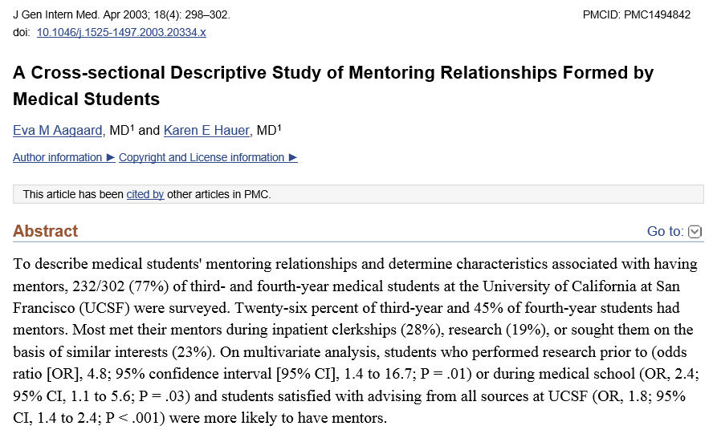

Questions:
- What makes this study design cross-sectional?
- What is the outcome of interest in this study?
- What associated characteristics were investigated?

When designing a cross-sectional study, one must ensure that the sample is representative of the population of interest. The best way to prevent bias is to ensure that random sampling methods are used. Also, one should keep the following advantages and disadvantages of using this type of study in mind.
Cross-Sectional Study
Advantages | Disadvantages
- Relatively inexpensive and can be completed quickly  - Allows for estimation of the prevalence of the outcome of interest  - Allows for the assessment of many outcomes and risk factors  - There is no loss to follow-up | - Doesn’t allow for causal inference  - If conducted at a different point in time, the study could provide different conclusions

Like the cross-sectional study, the next type of study can also be carried out fairly quickly; however, it involves data that has been recalled or collected from the past.
Case-control (Retrospective) Study
In a case-control study, two groups of individuals are initially identified: (1) a group that has the disease under study (the cases) and (2) a group that does not have the disease under study but is as similar as possible to the cases (the controls). Cases are then compared to controls to assess whether they differ on explanatory variables of interest (e.g., their prior health habits or exposure to risk factors). This is also called a retrospective study because it involves data that was recalled from or collected in the past.

Example: Case-Control Study Investigating Mobile Phone Use and Cancer
From the methods section:
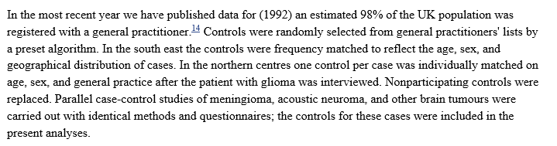
Questions:

- Who are the cases?
- Who are the controls?

- Were the cases matched with controls on an individual basis? If so, what characteristics were used as matching criteria?

- How is matching cases and controls similar to a matched-pair experimental design? How is it different?

Case-Control Study
Advantages | Disadvantages
- Relatively inexpensive and can be completed quickly  - Controls can be chosen to reduce the effect of potential confounding variables  - Allows for the investigation of rare diseases or diseases with a long induction period | - Doesn’t allow for causal inference  - Doesn’t ensure that the exposure preceded the disease  - It is difficult to select both cases and controls who are representative of their respective populations  - People may not remember past events accurately  - Doesn’t allow us to estimate the prevalence of a disease
Finally, the third type of observational study involves following participants into the future rather than analyzing data from the past.

Cohort (Prospective) Study
In a cohort study (also called a longitudinal study), a group of disease-free individuals (the cohort) is identified at one point in time, and information is obtained to determine which members of the cohort are exposed to the factor of interest. The subjects are then followed over a period of time until some of them develop the disease, and the incidence of the disease in the exposed individuals is compared with the incidence in those not exposed. This is also called a prospective study because it involves following participants into the future.

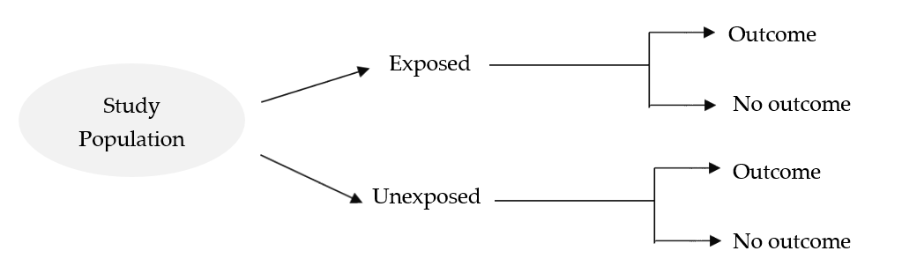

Example: Cohort Study Investigating Methamphetamine Use and Schizophrenia
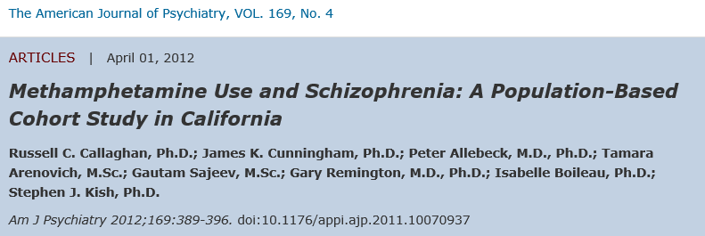

Cohort Study
Advantages | Disadvantages
- Ensures that exposure precedes the disease  - Can be used to study more than one outcome  - Good for the study of rare exposures  - Allows for the incidence of the outcome to be measured | - Doesn’t allow for causal inference  - Can be costly and may take a long time  - When studying rare outcomes, a very large sample size is required  - Prone to dropout

FINAL COMMENT ON REPRESENTATIVE SAMPLES

When interpreting both randomized experiments and observational studies, keep in mind that the data collected can be used to make inferences about the larger population if the sample can be considered representative of the population. In the next chapter, we’ll discuss in detail strategies for obtaining samples.

When observational studies are based on random samples, it is reasonable to assume those samples are representative of the population from which they were drawn. Similarly, when the subjects in a designed experiment are first randomly selected from a population and then randomly assigned to treatment groups, it is reasonable to assume the subjects under study are representative of the population of interest.
When observational studies or designed experiments use volunteers, however, one should think carefully about whether the results should be extended to a specific population.

