Systematic Sampling HW Assistance
The following process explains the implementation of systematic sampling in R. For this example, estimating Grade is of interest. It is know that DaysSkipped is thought to impact Grade; thus, systematic sampling will be used to obtain a Grade across the entire spectrum of the DaysSkipped variable.
- Step 1: Read-in original data
- Step 2: Sort the data.frame by a variable (DaysSkipped here) that is thought to impact the response variable (Grade here).
Original Data  Data <- read.csv(file.choose())  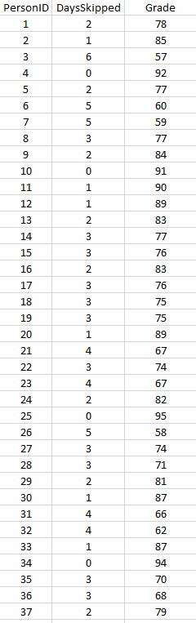 | Data Sorted by DaysSkipped  library(dplyr)  Data2 <- arrange(Data,DaysSkipped)  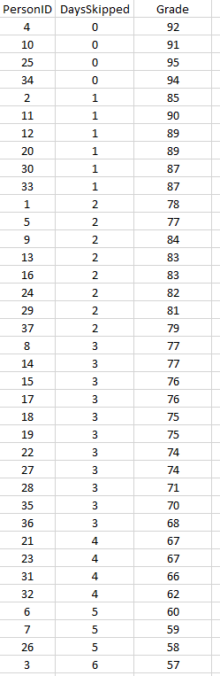

- Step 3: After the data has been sorted, create a RowIndex variable.
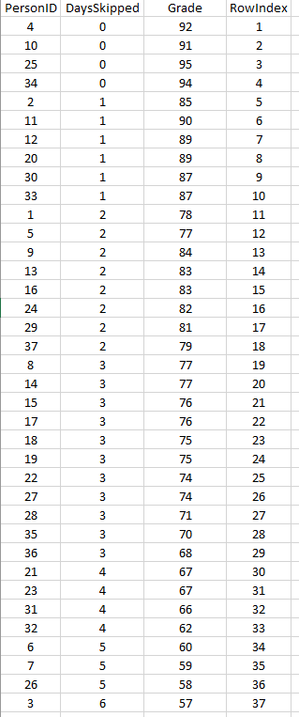 | Adding a unique row index to the data.frame  Data2 <- mutate(Data2,RowIndex = seq(1,37,1))

The total number of rows in this data.frame is 37. Suppose the desired sample size is 5.
37 / 5 = 7 r 2
The fact that the math does not come out evenly complicates things a bit. For example, if there were 35 total rows with a desired sample size of 5, then there would be 7 rows in each group. However, for this example, there will be 7 people in most groups, but the last group will have a total of 9 (7 + 2 extra).
Desired sample size = 5  Total Number of Rows = 37  37 / 5 = 7 r 2  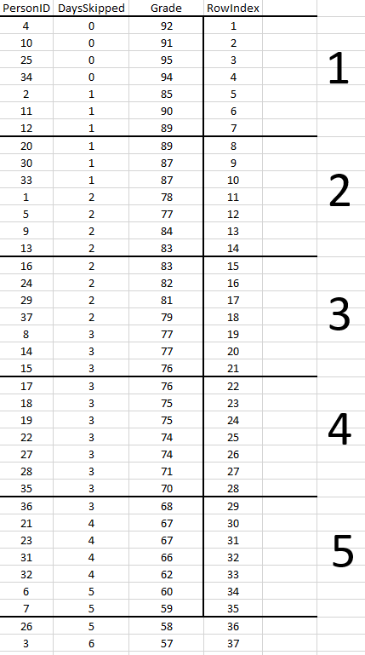 | Groups 1 – 4 will each have 7 people  and Group 5 will have (7 + 2 ) people  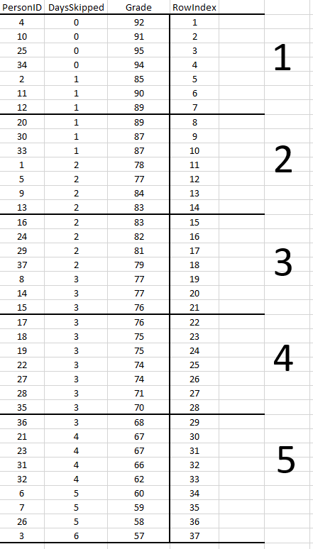
- Step 4: Use modular arithmetic to create a repeated pattern for each of the 5 groups.
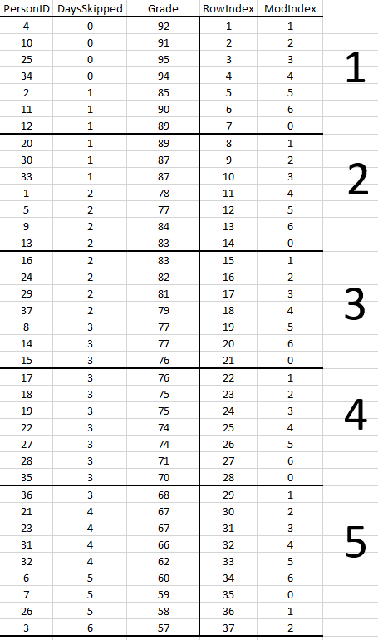 | Adding an index that is repeated for each group.  Data3 <- mutate(Data2,ModIndex = RowIndex %% 7)

- Step 5: Obtain a random integer to identify the row will be used from each group.
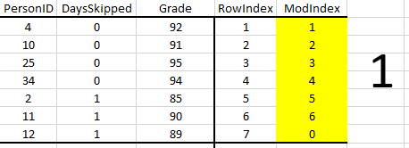 | Adding an index that is repeated for each group.  > sample(0:6,size=1)

The fact that the last group has 9 (instead of 7) people may result in too many people being selected for the sample. The implication of this is that you may end up with 1 additional observations in your sample – which may or may not be a big deal.
Works as intended  Sample Size = 5  > sample(0:6,size=1)  [1] 5  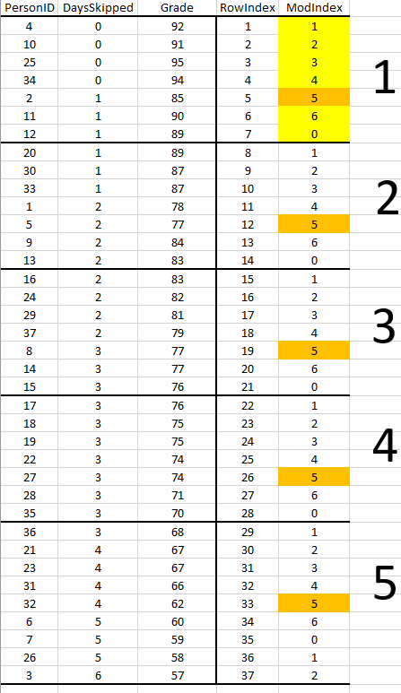 | Does not work as intended  Sample Size = 6 (not 5 as intended)  > sample(0:6,size=1)  [1] 2  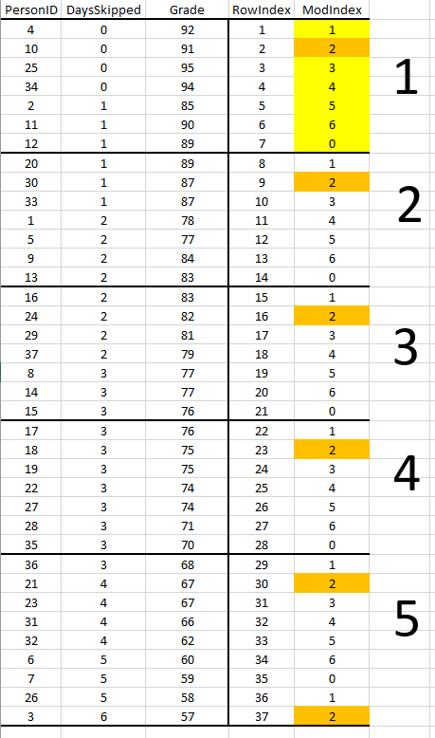

The following procedure can be used to obtain the desired sample size (exactly).
  - Divide the sampling into two pieces: 1) Part 1 - randomly selected rows using the systematic sampling process. The randomly selected rows will be taken from all group except the last group. 2) For the last group, obtain a simple random sample of size 1 from the rows in the last group.
PART 1 | Systematic Sampling for Groups 1 – 4  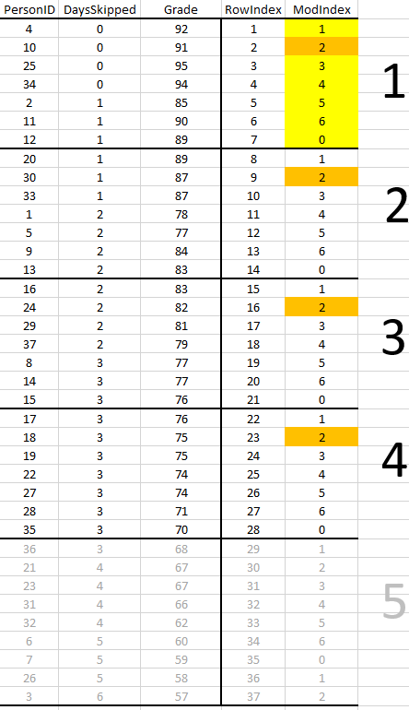 | Part1 <- Data3  %>% filter(RowIndex <= 4*7)  %>% filter(ModIndex == 2)
PART 2 | Simple random sampling for Group 5  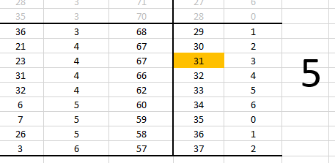 | > sample(29:37,size=1)  [1] 31  Part2 <- filter(Data3,RowIndex == 31)
Finally, concatenate the two parts into single data.frame, say SampleData.
> SampleData <- bind_rows(Part1,Part2)
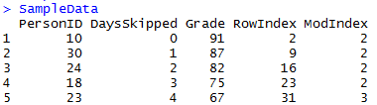
The following use of the select() function can be used to keep only the columns of interest.
FinalSampleData <- select(SampleData,PersonID,DaysSkipped,Grade)
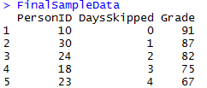
Finally, compute the statistic of interest.
> summarize(FinalSampleData, "Estimate" = mean(Grade))
Estimate
1 80.4

The following function puts all these pieces together and can be used to accomplish systematic sampling for the data used in this example.
SystematicSample <- function(){
getmodindex <- sample(0:6,size=1)
Part1 <- Data3 %>% filter(RowIndex <= 4*7) %>% filter(ModIndex == getmodindex)
getlastrowindex <- sample(29:37,size=1)
Part2 <- filter(Data3,RowIndex == getlastrowindex)
SampleData <- bind_rows(Part1,Part2)
FinalSampleData <- select(SampleData,PersonID,DaysSkipped,Grade)
output <- summarize(FinalSampleData, "Estimate" = mean(Grade))
return(output)
}
Using this function to obtain an estimate for average grade.
> SystematicSample()
Estimate
1 78

