STAT 335: HW #1 Name: ______________________________
Fall 2018
Points: 25

- Does eating dinner with their families improve students’ academic performance? According to an ABC News article, “Teenagers who eat with their families at least five times a week are more likely to get better grades in school.” This finding was based on a sample survey conducted by researchers at Columbia University. (5 pts)

- Is this an observational study or an experiment? Explain your reasoning.
- What is/are the explanatory variable(s)?
- What is/are the response variable(s)?
- Explain clearly why such a study cannot establish a cause-and-effect relationship. In this explanation, suggest a variable that may be confounded with whether or not families eat dinner together.
- Suppose that a chemical engineer is designing the production process for a new product. The chemical reaction that produces the product may have higher or lower yield, depending on the temperature and the stirring rate in the vessel in which the reaction takes place. The engineer decides to investigate the effects of combinations of four temperatures (50ºC, 60ºC, 70ºC, 80ºC) and two stirring rates (90 rpm, 120 rpm) on the yield of the process. She will process two batches of the product at each combination of temperature and stirring rate. (5 pts)
  - What is the response variable?
  - What are the explanatory variables?
  - Identify the factor(s) and levels of the factor(s) under study.
  - How many treatments exist, and what are they?
  - What are the experimental units, and how many are required?

- An experiment was conducted to compare the effect of four different compositions of feed for calves on their weight gain. The calves were not fed individually; instead, they were housed in four pens, with ten calves per pen. Each pen was allocated to a certain type of feed. Batches of this type of feed were put into the pen, and calves were free to eat as much of this as they liked. Calves were then weighed individually in order to determine their weight gain (note that they were also weighed at the beginning of the study prior to receiving any treatment). (5 pts)
  - Identify the response variable.
  - Identify the treatment factor and the levels.
  - Identify the experimental unit.
  - Discuss any problems you see with how this study was conducted, and propose an improved study design. Sketch a diagram to describe your setup, and also clearly discuss how your new design employs the concepts of control, randomization, and replication.

- A psychologist wants to know if the difficulty of a task influences our estimate of how long we spend working at it. She designs two sets of mazes that subjects can work through on a computer. One set has easy mazes and the other has difficult mazes. Subjects work until told to stop (after 6 minutes, but subjects do not know this). They are then asked to estimate how long they worked. The psychologist has 30 students available to serve as subjects. (5 pts)
  - Describe an experiment using a completely randomized design to learn the effect of difficulty on estimated time. Sketch a diagram to describe your setup, and also clearly discuss how your new design employs the concepts of control, randomization, and replication.

  - Describe a matched pairs experimental design using the same 30 subjects. Again, sketch a diagram to describe your setup, and also clearly discuss how your new design employs the concepts of control, randomization, and replication.

- Answer the following questions regarding blocking. (5 pts)
  - What is the purpose of blocking in an experiment?
  - Give an example of when we shouldn’t block (e.g., describe a scenario where a randomized complete block design is not preferable to a completely randomized design).
  - Suppose you are investigating the effect of two treatments on the response. There are 20 subjects available for the study. You know in advance that another variable is also related to the response, so you decide to use it as a blocking factor. Provide a situation for when Design A may be preferred over Design B?
Design A:
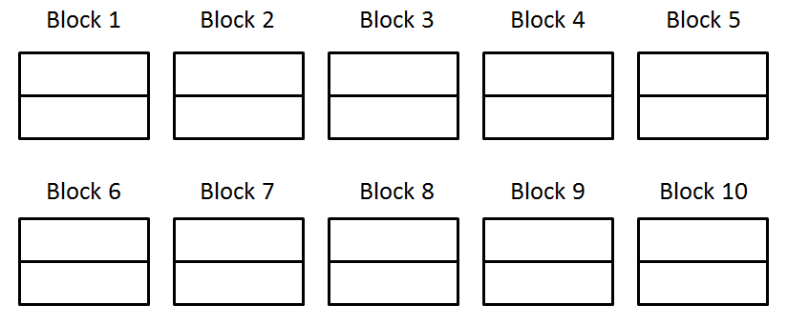
Design B:
